**Project 4 - texture**

Screenshot:

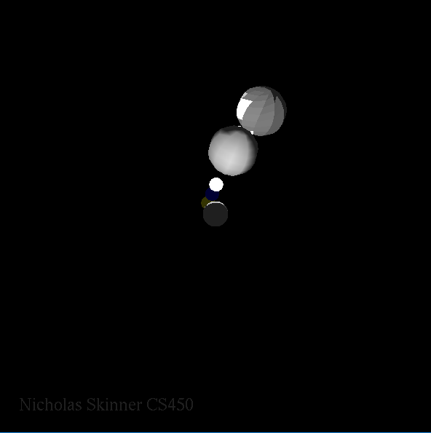

Video Link: <https://media.oregonstate.edu/media/0_x8pb0ugn>

Thanks, and have a great day!